Head First SCWCD
Unit 1

WebServer: A WebServer takes a client request and return back some resource to the client, normally Static resource. Ex: Apache Web Server.
404 Error, when a request asked is not found on server.

WebServer: Apache
WebClient: Browser

CLIENT to SERVER
Browser (Request through link)→ HTTP → WebServer
Request has 3 parameters
- Request Line
  - Protocol method type (GET or POST)
  - URL
  - Protocol version
- Request Headers (Host, User-Agent(Browser name), Accept)
- Input to the server (get(part of url) or post(sent after header))
GET EXAMPLE
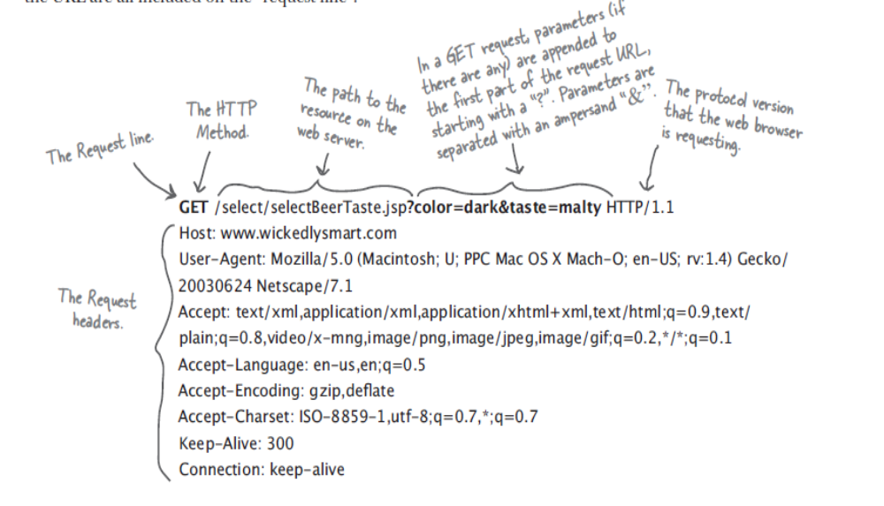

POST EXAMPLE

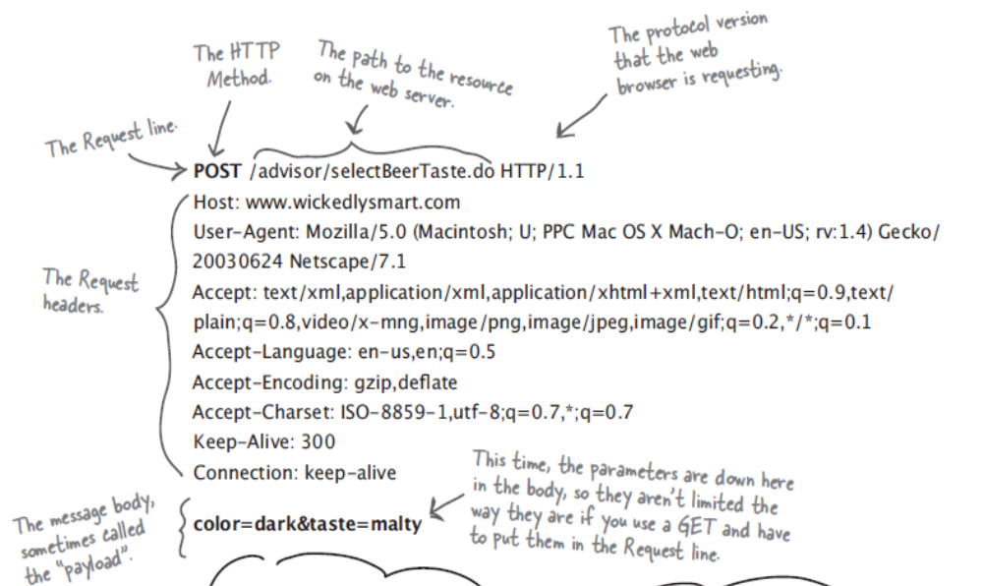
SERVER to CLIENT
WebServer (Response(HTML or jpg,pdf or other resources))→ HTTP → Browser(renders if it is HTML else if image directly display else if PDF use plugin to display the PDF)

Difference between GET and POST
- Limited data on Get , Unlimited data on POST
- Get can be saved like bookmarks, post not possible
- Get shows the data on url, so passwords hidden is not possible, whereas post it is possible.
Response has 4 parameters

- Response Line
  - Protocol Version
  - Response code(404 not found, 200 success)
  - Response status (OK, ERROR)
- Response Headers (Content type)
- Response Body

Serving Dynamic Resource: Web Server uses helper application to handle dynamic resources. One such helper application is Tomcat.
EX: Serving the current time to the client.
Apache Tomcat is a Servlet container developed by the Apache Software Foundation (ASF). Tomcat implements the Java Servlet and the JavaServer Pages (JSP) specifications from Sun Microsystems, and provides a "pure Java" HTTP web server environment for Java code to run.

Apache web server, which is a C implementation of an HTTP web server

So whenever web server gets a request, if it is a dynamic resource (other than JPG, or PDF) it will handle the request to the helper application and waits for the response. Once it gets the response from the helper application it will send the same to the client.

CGI-Perl disadvantages
- Perl is Heavy weight process

Servlet View: HTML inside JAVA
JSP View: JAVA inside HTML

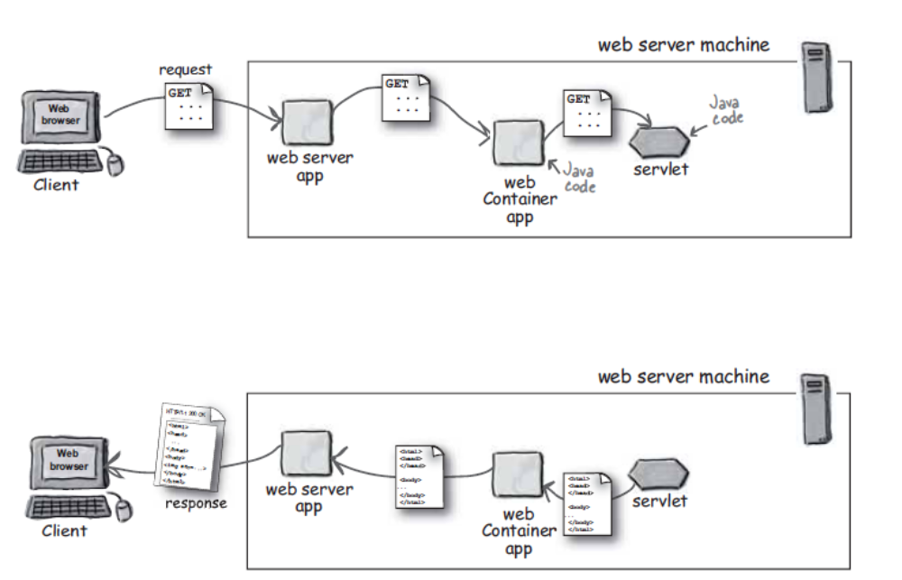

Possible things to do if the web container is not present
- Socket connection to get and deliver request and response from webserver
- Thread to handle multiple instance of servlet
- Memory management
- Support for JSP
- Support for Security

A servlet is said to have its property, when a class extends HttpServlet and overrides any of doXXX method

First method called on the servlet
The servlet we write needs to extend HttpServlet.

The container handles the request to the service method of HttpServlet and waits for the response.

The servlet doesn’t have a main method instead it has a service (which is present in HttpServlet class) method which decides the first method to call. If the request from browser is get then service calls doGet(), if it is post then the service calls doPost().
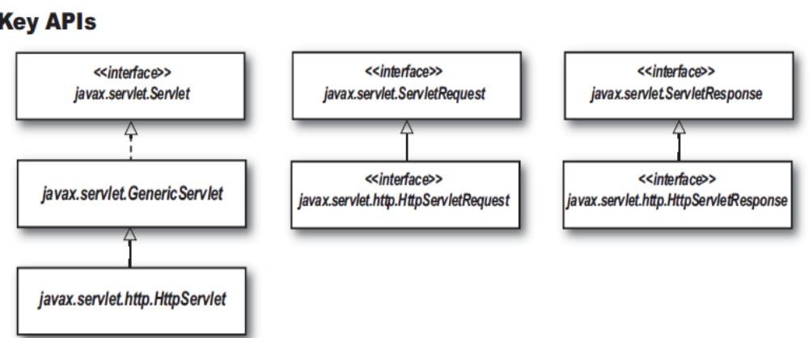
javax.servlet.Servlet → javax.servlet.GenericServlet→ javax.servlet.http.HttpServlet

public interface Servlet

public abstract class GenericServlet
extends java.lang.Object
implements Servlet, ServletConfig, java.io.Serializable

public abstract class HttpServlet extends GenericServlet

public void service(ServletRequest req, ServletResponse res)
Dispatches client requests to the protected service method.

protected void service(HttpServletRequest req,HttpServletResponse resp)
Receives standard HTTP requests from the public service method and dispatches them to the doXXX methods defined in this class.

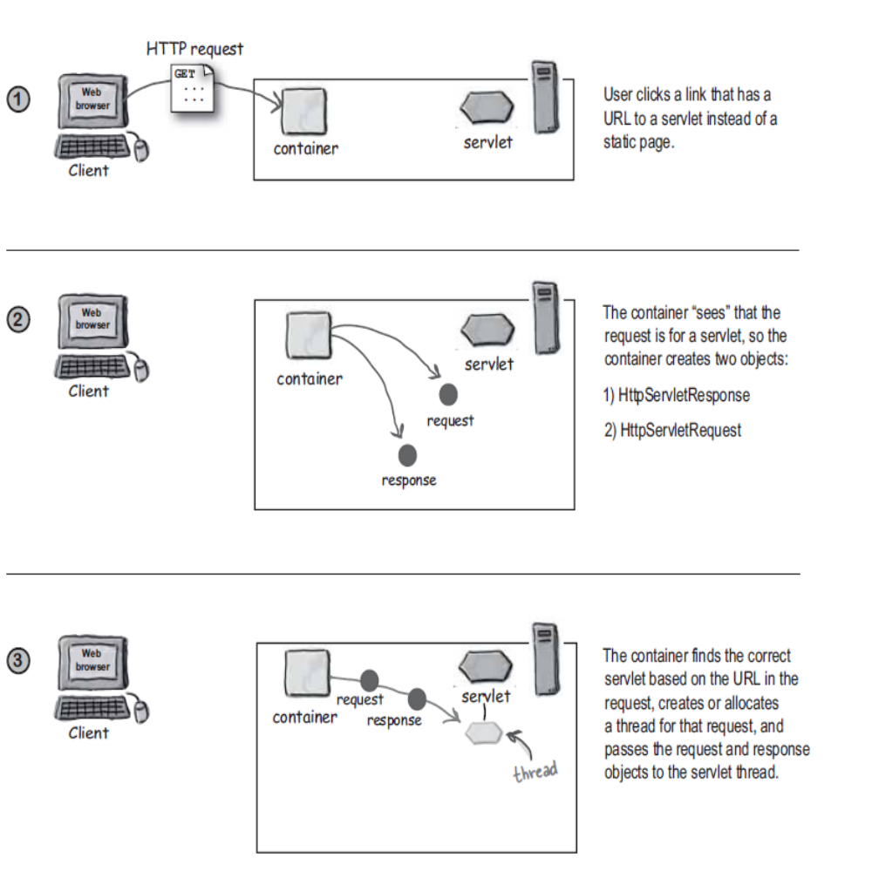
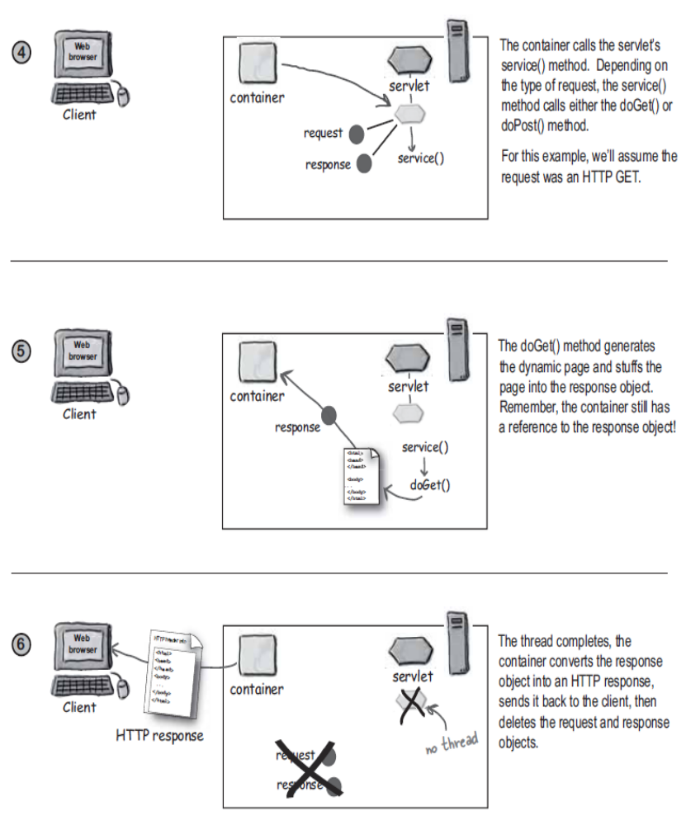

Making MVC from JSP and servlet

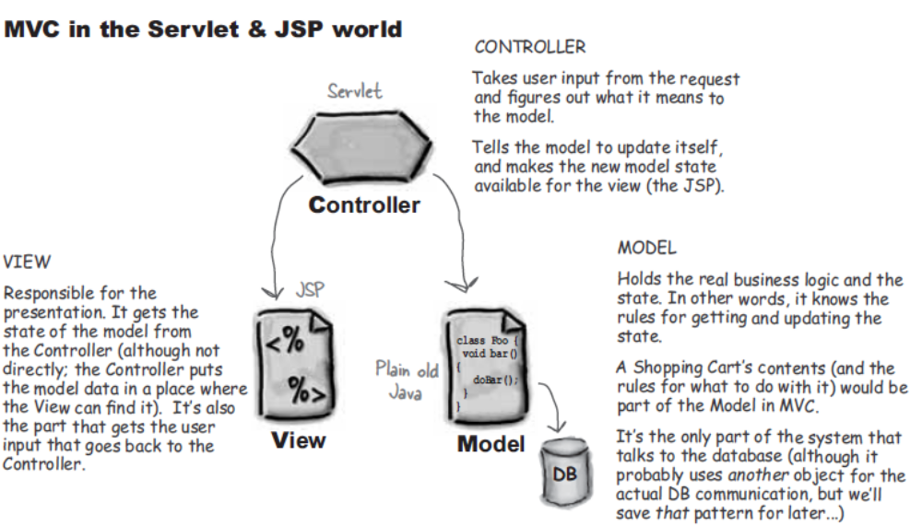

Tomcat is just a webcontainer
J2EE application server is webcontainer and EJB container

Request.getInputStream()→ this method is used to get raw bytes of data EX: file upload from client

1st getHeader and 2nd getIntHeader→ if the header is of integer type then 2nd one is used.

Everything with respect to server, because servlet runs on server
getRemotePort→ client port
getServerPort→ server listening port
getLocalPort→ binding port for server and client to server a specific client(a case when a request got from client, the server allocates a separate thread)

Response data is of 2 types
- Raw Stream or bytes
Example
byte[] bytes = new byte[1024];
ServletContext ctx = getServletContext();
InputStream is = ctx.getResourceAsStream(“filename”);
OutputStream os = response.getOutputStream();
Int read = 0;
While(read = is.read(bytes) != -1) {
os.write(bytes, 0, read)
}
- Charater Stream
Example
Printwriter out = response.getWriter();
out.println(“Welcome”);

SendRedirect
Saying response.sendRedirect(“string url, not URL object”)→means the servlet sets Location header as string url in reponse and it will be back to client. On seeing the Location header client simply try for another url without user invention.
Note: response write call should not be used, after or before calling SendRedirect, which in turn cause an IllegalStateException

RequestDispatcher
RequestDispatcher view = request.getRequestDispatcher(“string url”);
view.forward(request, response);
The server itself forwards the request to a another servlet.

view.include
public void include(ServletRequest request,
ServletResponse response)
throws ServletException,
java.io.IOException
Includes the content of a resource (servlet, JSP page, HTML file) in the response. In essence, this method enables programmatic server-side includes.

Differnece between SendRedirect and RequestDispatcher
1) In SendRedirect, Client knows the redirected url.
2) RequestDispatcher is fast.
3) SendRedirect can take a absolute url.. which can point to a different webserver, whereas RequestDispatcher supports only relative url.

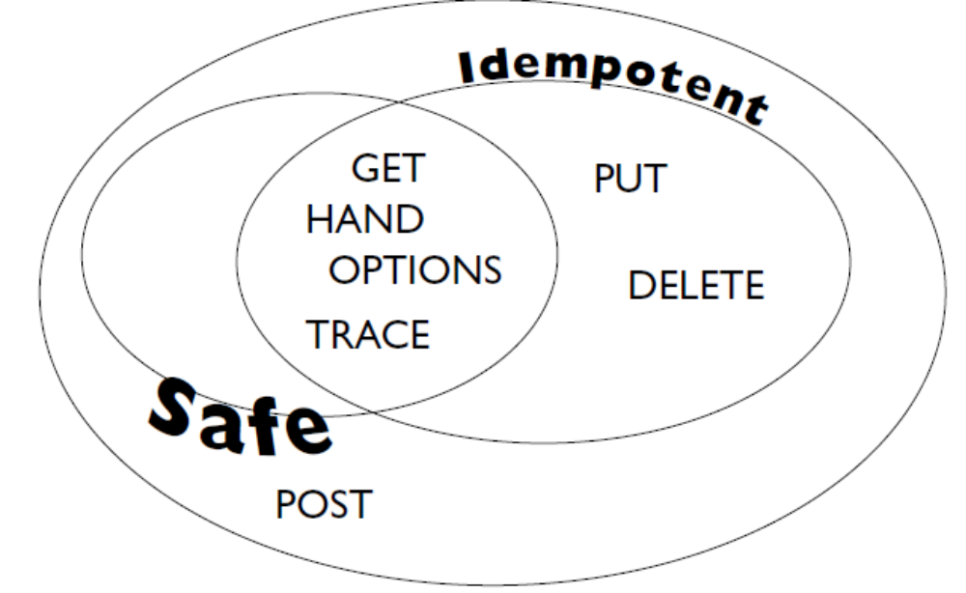
Except POST all the 6 methods are considered idempotent

ServletConfig and ServletContext

ServletConfig: Used to interact with individual servlet, it is one per servlet.
Package name: javax.servlet
Class name: Interface ServletConfig
All Known Implementing Classes:
GenericServlet
Method to get ServletConfig: getServletConfig()
ServletContext: Used to interact with servlet container, it is one per application.
Package name: javax.servlet
Class name: Interface ServletContext
No Direct implementation…….The ServletContext object is contained within the ServletConfig object, which the Web server provides to the servlet when the servlet is initialized
Method to get ServletConfig: getServletContext()

When a container initializes a servlet it makes a unique ServletConfig for that servlet. The container reads the DD’s init parameter for the servlet and assign it to the ServletConfig.
<servlet>
<servlet-name> </servlet-name>
<servlet-class> </servlet-class>
<init-param>
<param-name>param1</param-name>
<param-value> prabhu</param-value>
</init-param>
</servlet>

ServletConfig sc = getServletConfig();
sc.getInitParameter(“param1”);

Attributes:

public void setAttribute(String name,Object value)
public Object getAttribute (String name)
public Enumeration getAttributeNames()
public void removeAttribute (String name)

request.setAttribute("username","marcus");
session.setAttribute("username","marcus");
application.setAttribute("username","marcus");

Request scope lasts from the moment an HTTP request hits a servlet in your web
container to the moment the servlet is done with delivering the HTTP response.
More accurately, the request scope is available from entry into a servlet’s service()
method up to the point of exit from that method.

Session scope comes into play from the point where a browser window establishes
contact with your web application up to the point where that browser window
is closed.
HttpSession session = request.getSession();

servlet context attributes like servlet context parameters.
Use of Servlet Context: Global variable for application like CopyRight info, Email address.

1)call a method of another Servlet
2)call another Servlet (or any other kind of active resource) to process a request
3)access a resource in the server's document tree
Passive server resources (e.g. static HTML pages which are stored in local files) are not accessed with RequestDispatcher objects. The ServletContext method getResource(String path) returns a URL object for a resource specified by a local URI (e.g. "/" for the server's document root) which can be used to examine the resource.
If you only want to read the resource's body you can directly ask the ServletContext for an InputStream with the getResourceAsStream(String path) method.
4)share data between Servlets

Listeners
- ServletConfig will hold init detail for each servlet.
- ServletContext will hold init detail for whole web-app. When a web-app is deployed a ServletContext object is created and assigned with <context-param> values.
Both ServletConfig and ServletContext can hold only String. Assume there is a situation where we require database object in init param..HERE COMES THE LISTENERS. ServletContextListener reads ServletContext during web-app deployment and set a attribute (DB object) under ServletContext. So that every servlet can get a DB Object.
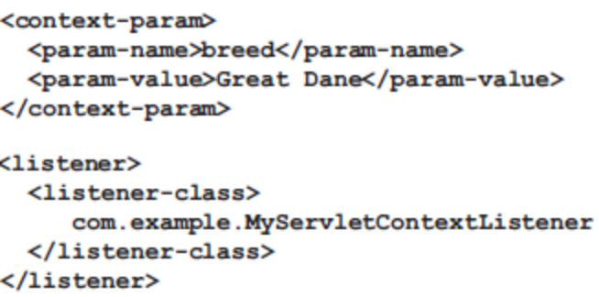

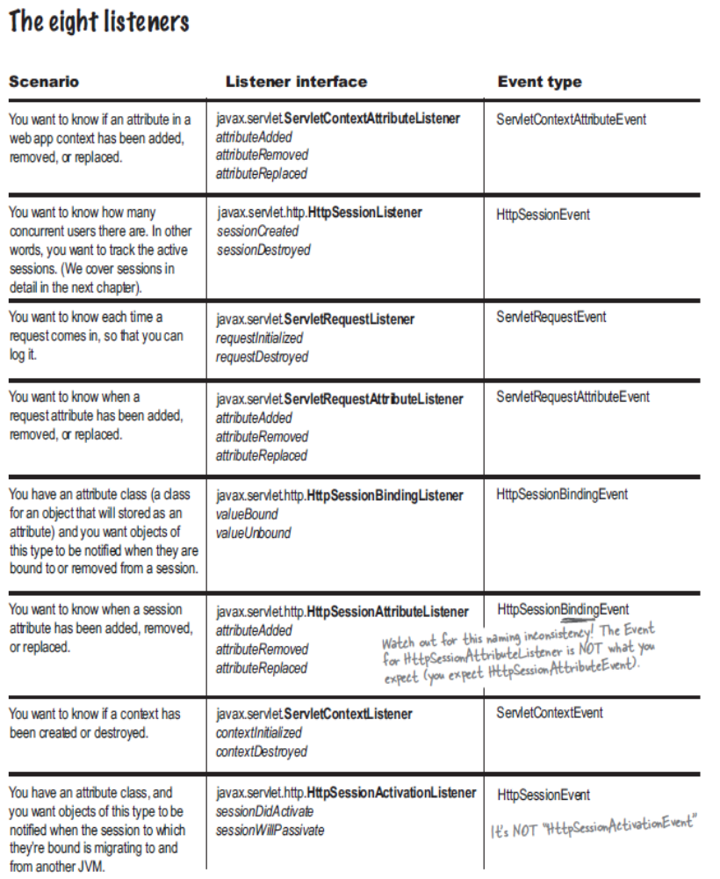

Maintaining States (Persisting client browser)
Http is a stateless protocol, meaning.. when a request and response is done. Neither browser nor the server knows about each other.
Maintaining states in 2 ways
- Set session Id as cookie-->a small file traded between the web. It is part of the header.
HttpSession session = HttpServletRequest.getSession();
The above statement will automatically insert a cookie,
Server sends→ Set-Cookie:JSESSIONID=45
Client sends → Cookie:JSESSIONID=45in the header by the container. No need for the user to keep track of sessions further. If the session exists container returns the session else creates a new session. If we don’t want to create a new session then use
HttpSession session = HttpServletRequest.getSession(false);

Disadvantage: If cookies is disabled in browser, then HttpServletRequest.getSession() will always create new session.

A client with cookies disabled, will ignore “Set-Cookie” response headers.

- URL rewriting-->having the session ID embedded in the URL. This method will not work for static pages.
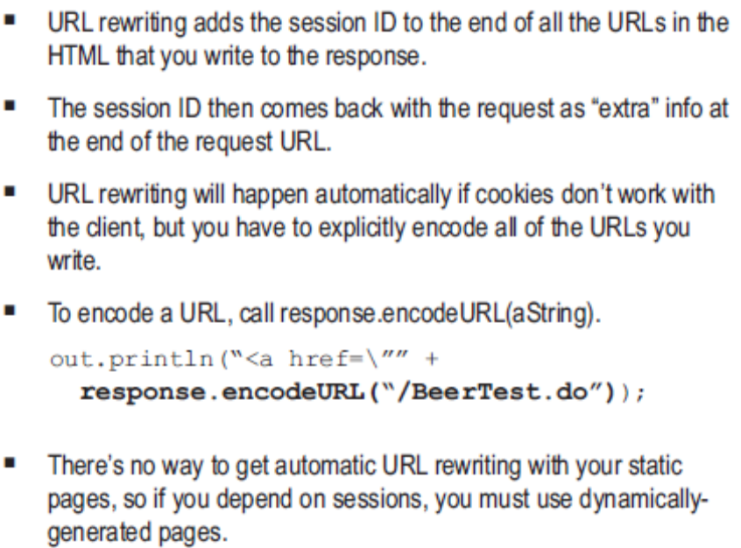

HttpSession session = HttpServletRequest.getSession();
is a shorthand form of
HttpSession session = HttpServletRequest.getSession(true);
default: HttpSession session = HttpServletRequest.getSession(false);

<web-app>
<session-config>
<session-timeout>60</session-timeout>
</session-config>
</web-app>

Three ways a session can die
- Inactive for longer time. Set auto timeout in DD or auto timeout in code (session.setMaxInactiveInterval(20*60); Autotimeout in DD in minutes and code is seconds
- Inactive for longer time. Call session.invalidate();
- Server crashes or undeployed.

Unit 8
JavaBean Standard Actions(JSP Tag Library)

1) Controller Servlet sets the value (attribute) in bean (a class which its variables are set using setter), tags read it.
2) If the controllser servlet fails to sets the value in bean, then tag itself sets some default value and reads it.
3) Polymorphic bean reference. using a)type(interface and abstract) and b)class attribute
4) Getting the request parameters straight from JSP without going through controller servlet by using the JSP tag setter param attribute.

Disadvantage of JSP standard action
1))))) It cannot access the bean object value. Example. the bean class itself has variable of type object other than string and integer. Because <jsp:getProperty> allows only to access the properties of bean attribute and it will not allow to access bean properties property. Here comes the EL

if no scope is specified in JSP Tag then it is page scope

EL

EL dot (.) operator can access only map and bean
EL array ([ ]) operator can access map, bean, array and List

List overrides toString(). So printing ${List} will print all the contents of list

Something special about EL [ ] operator
- For arrays and List, inside square bracket datas are converted into int. EX: dog[“10”] and dog[10] are same. Whereas dog[hello] or dog[“hello”]will fail
- For map and bean, if inside square bracket data is not a string then it will search for the attribute in scope, get that value then put that vaule as key for the map or bean.

EL implicit objects
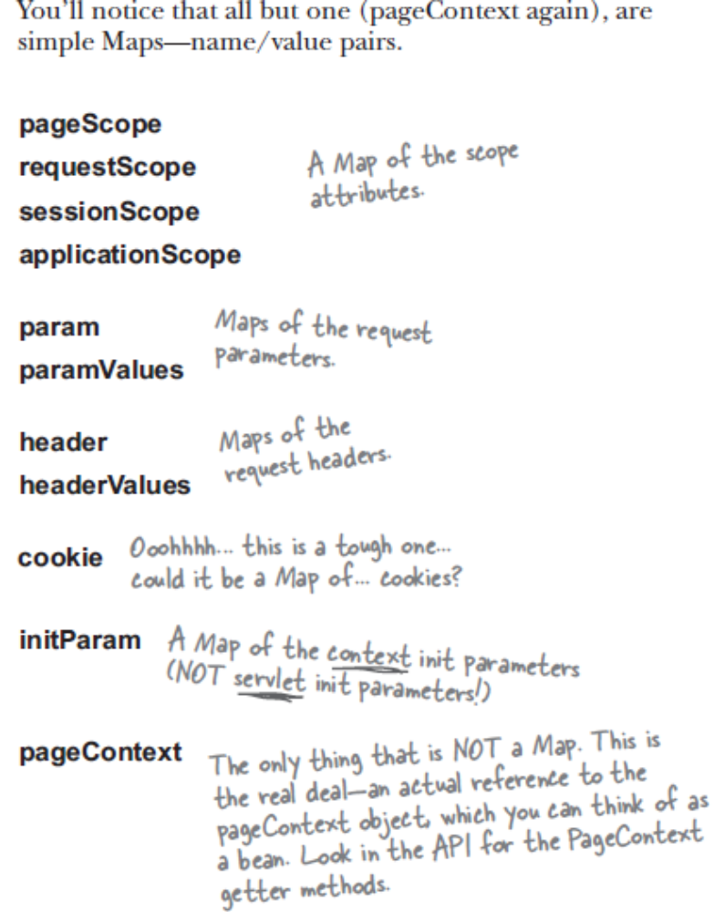

Request Attributes are placed in requestScope
Session Attributes are placed in sessionScope
Page Level Attributes are placed in pageScope
Application Attributes are placed in applicationScope

param used to get request parameters
paramValues used to get multiple value for one request parameter

header used to get header parameters
headerValues used to get multiple value for one header parameter

initParam used to get application level parameters

Through pageContext we can get everything apart from parameters and attributes of request, session, servletconfig
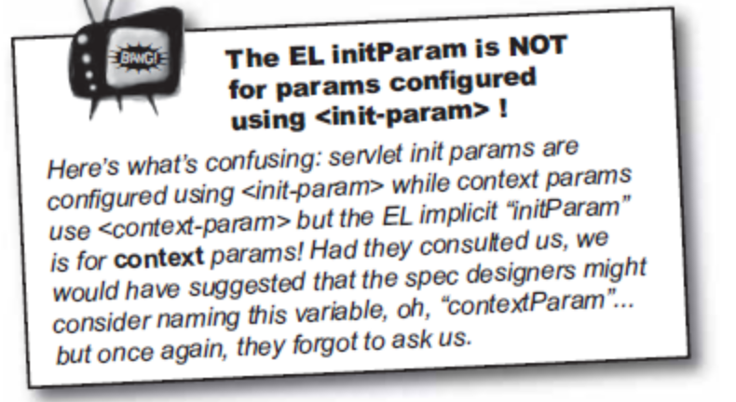

EL Functions

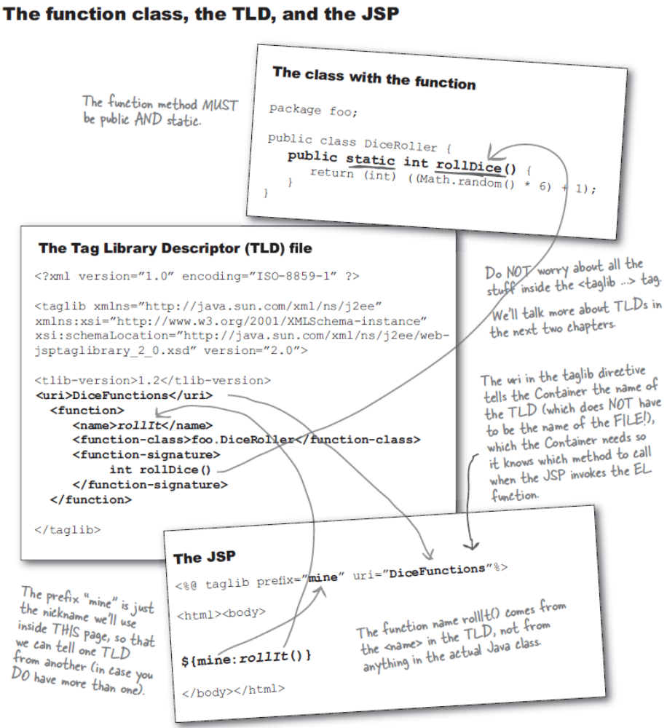

Headers and Footers include in JSP

1) Using include directive <%@ include file=”header.jsp”%>(include happens at translation time). So if there is a change in header.jsp, then it will not reflect (not guaranteed).
2) Using jsp standard action<jsp:include page=”header.jsp”>(include happens at runtime)

Note: including the jsp or html will include the entire file during compile time or runtime. This will have a issue like.. each jsp or html file will have <html><body>..</body></html>. So putting that content inside an another jsp might cause sometime issue in some browser. So don’t add such a tags in file which needs to be included, meaning that such a file will never can act standalone.

Never do flush and forward <jsp:forward> or view.forward… else the forward will throws IllegalStateException and forward will fail.

Applying “Conditional test” like “if else” is not possible in JSP standard actions or EL.. Here comes the JSTL

JSTL
JSTL provides an effective way to embed logic within a JSP page without using embedded Java (scriptlet) code directly.
JSTL has support for common, structural tasks such as
- Iteration and conditionals,
- Tags for manipulating XML documents,
- internationalization tags
- SQL tags.

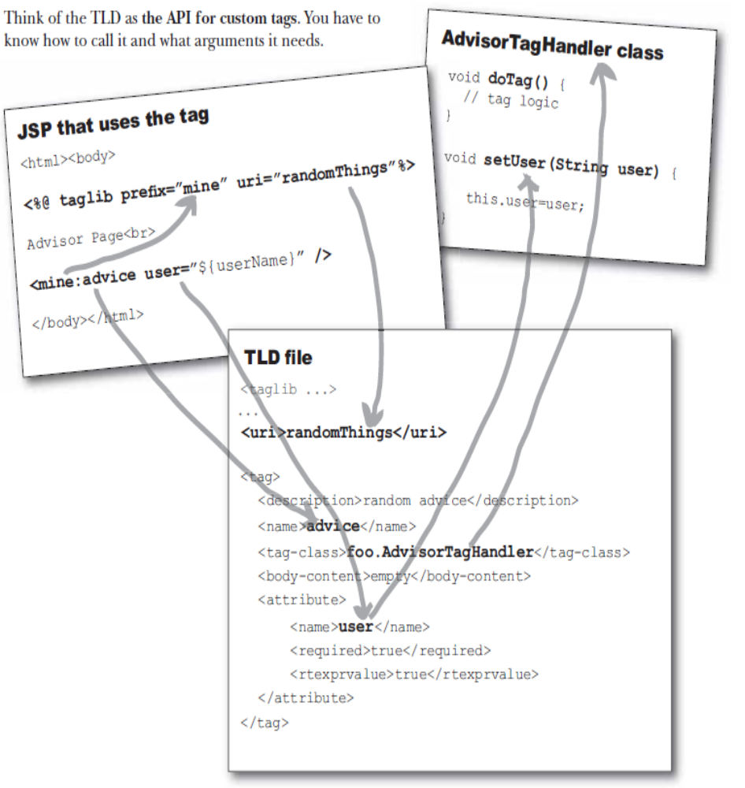
jsp custom tags
extends SimpleTagSupport. override doTag() pass attribute
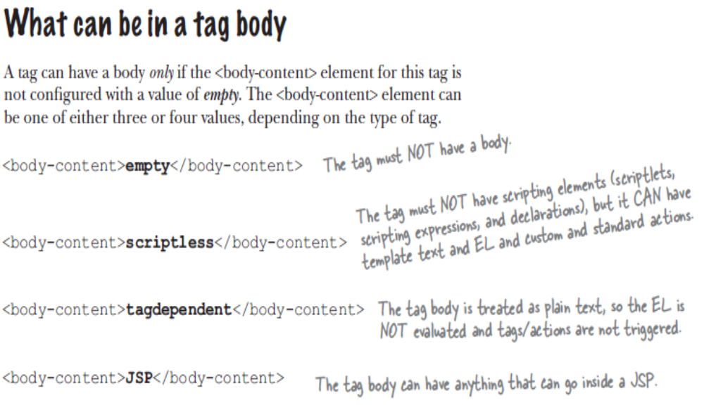
Difference between JSTL:include and custom include

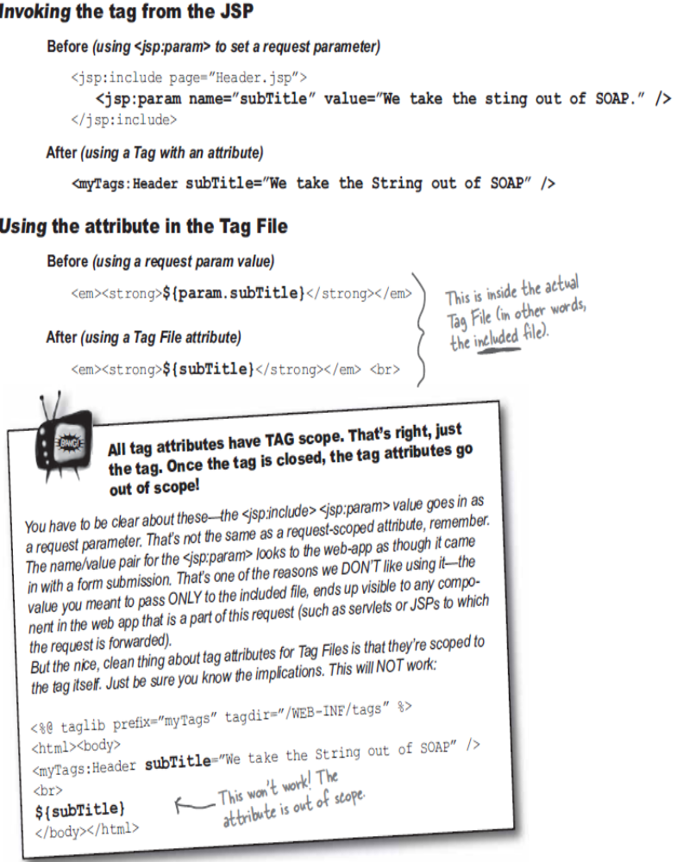

Various file types
- .java(model)
- .java(controller or servlet)
- .jsp
- .tld (Descriptor for Custom tags)
- .tag (like a JSP file.. mainly for including purpose. So that include options are simple. Descriptor for tag file is present inside tag file itself using <%@ attribute> attribute directive) page 506

Tag files are similar to <jsp:include>, but has a simple access way like.. <myTags:Header>
<myTags:Footer>

Tag files are included as part of JSP. So it has request and response objects and other properties of JSP.

Tag Body-Content is scriptless. It can be TagDirective (only plain text) or empty

If the application in deployed in JAR file, then tag file location needs to be specified in TLD file.

Filters

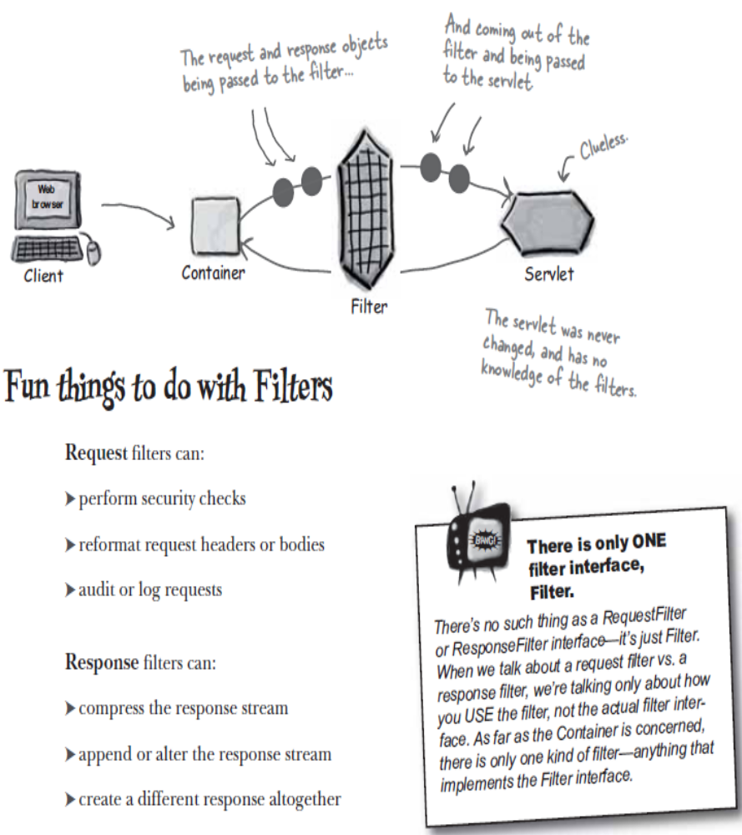

Life Cycle of Filters

- Init(must)
  - Init(FilterConfig config)
    - Config→ to get the init parameters configured in DD
- doFilter(must, which does the actual work)
  - doFilter(ServletRequest req, ServletResponse res, FilterChain chain)
    - req→Need to convert into HttpServletRequest for process
    - res→Need to convert into HttpServletResponse for process
    - chain→used for connecting to another filter
- destroy(must)
  - destroy()

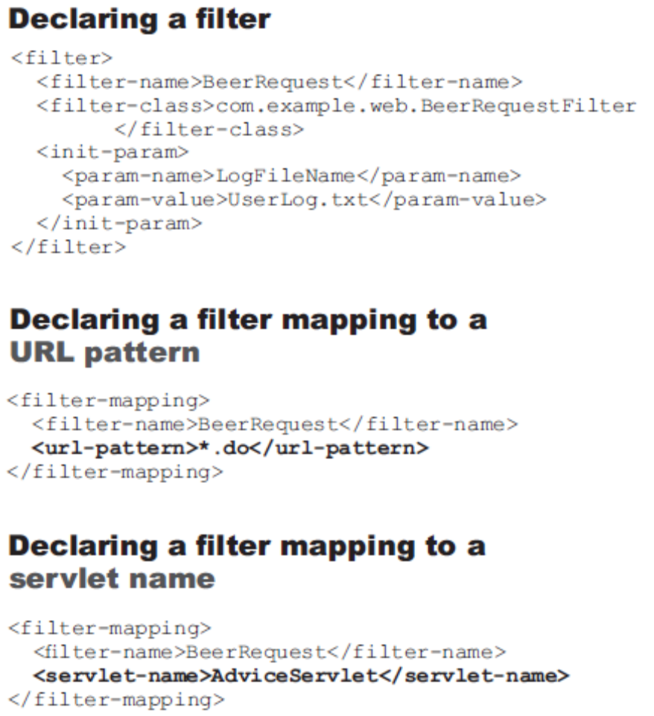

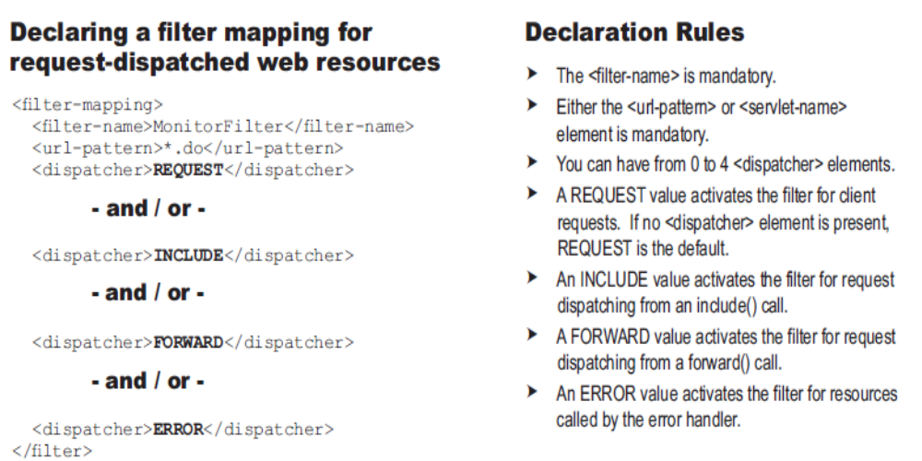

Security
- Authenticate (username and password)
- Authorization (assigning roles to users like admin,guest,Manager)
- Confidentiality (make sure data is unable to read by interruptor, )
- Integrity (make sure data is not changed by interruptor, HTTPS).

Authorization steps(2 step process)
- Define roles(Authentication details and roles in tomcat-users.xml)
- Define Resource/Method Constraints

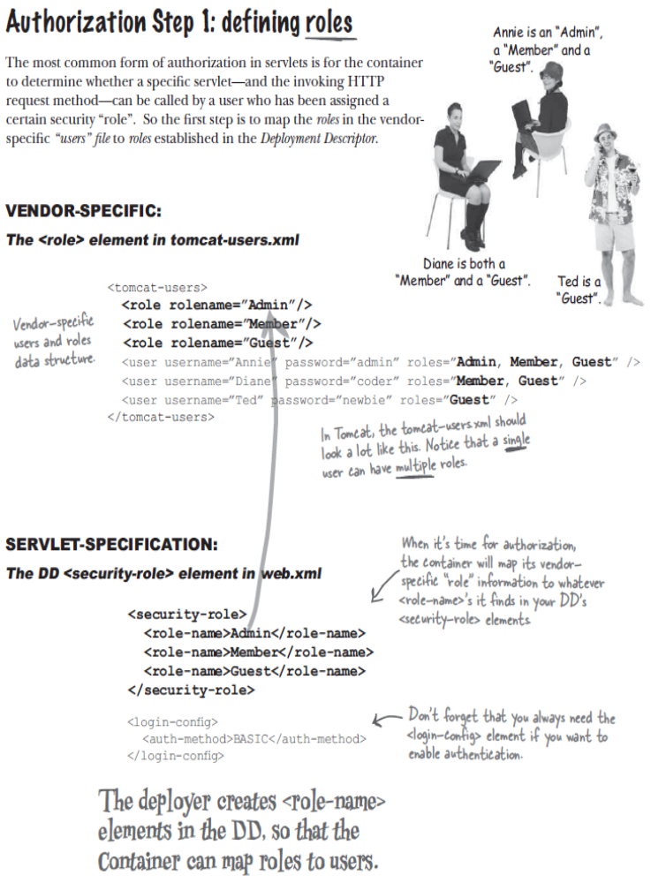

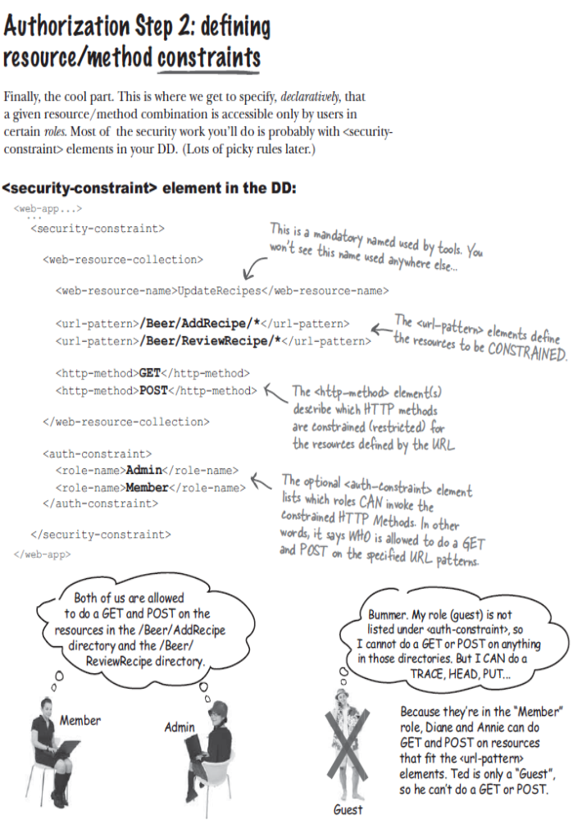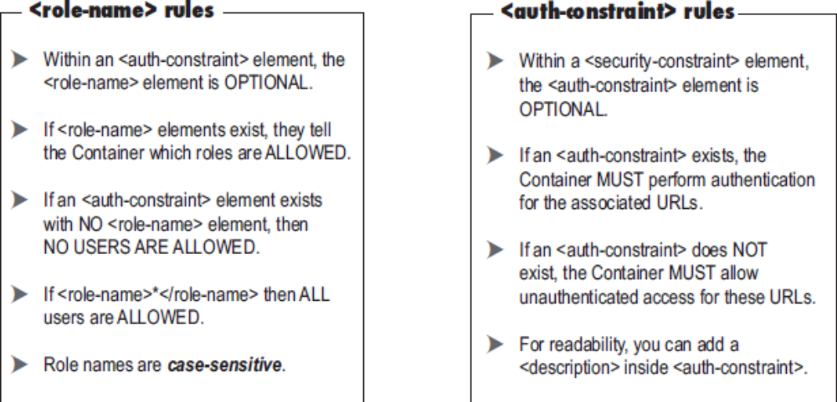

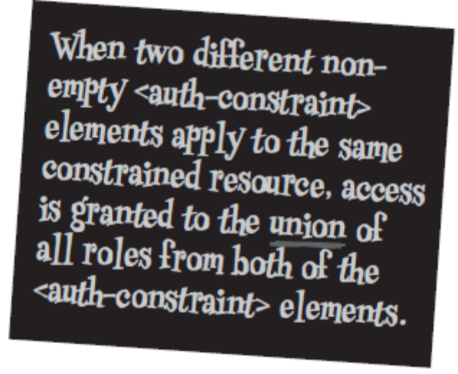
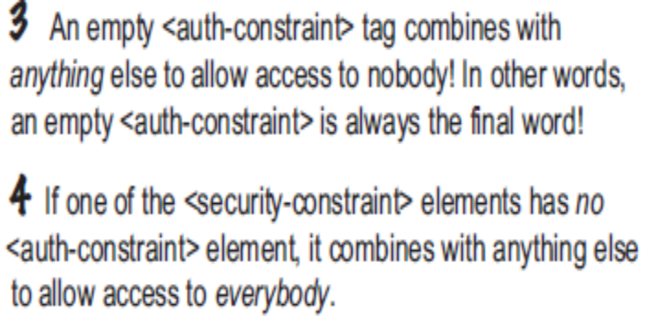
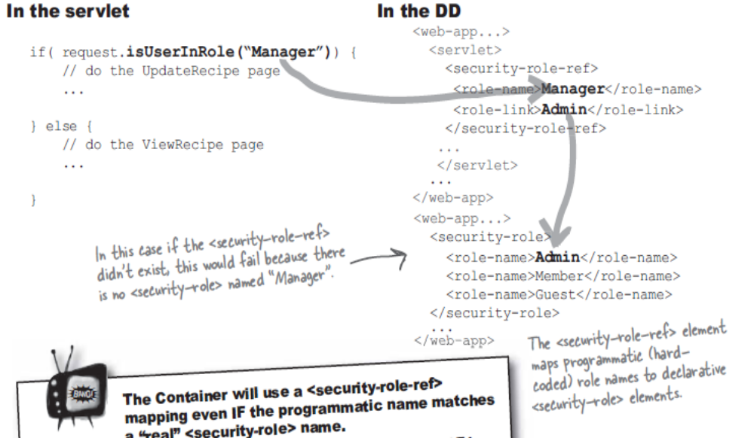

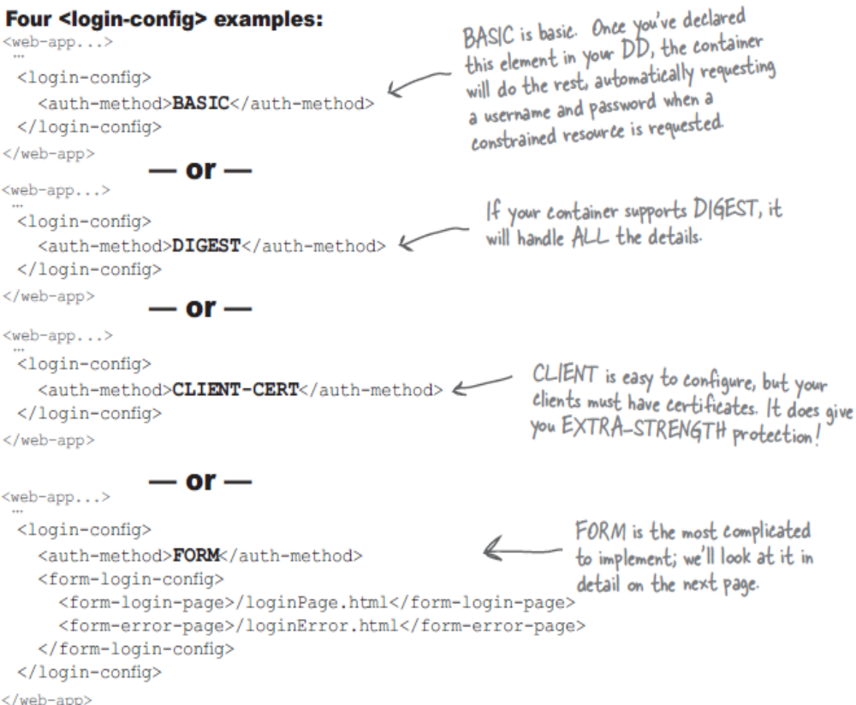

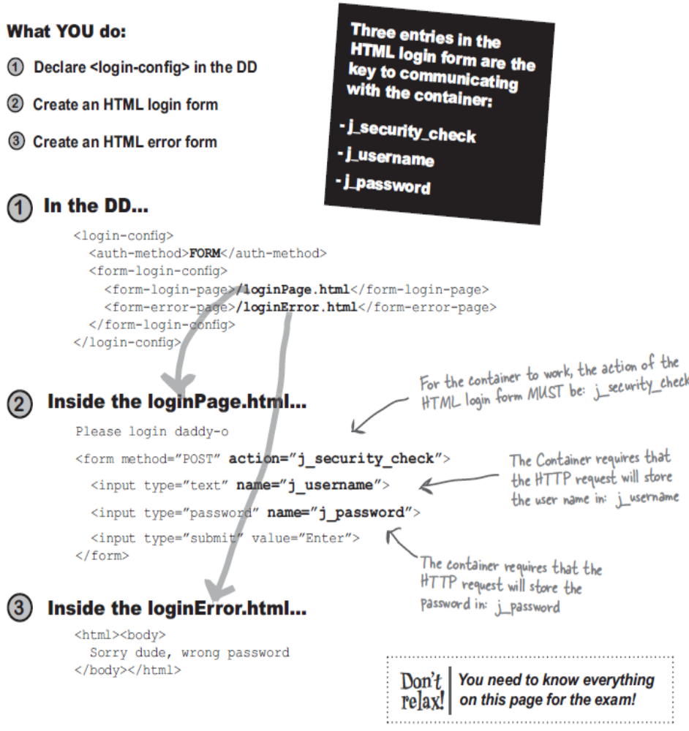

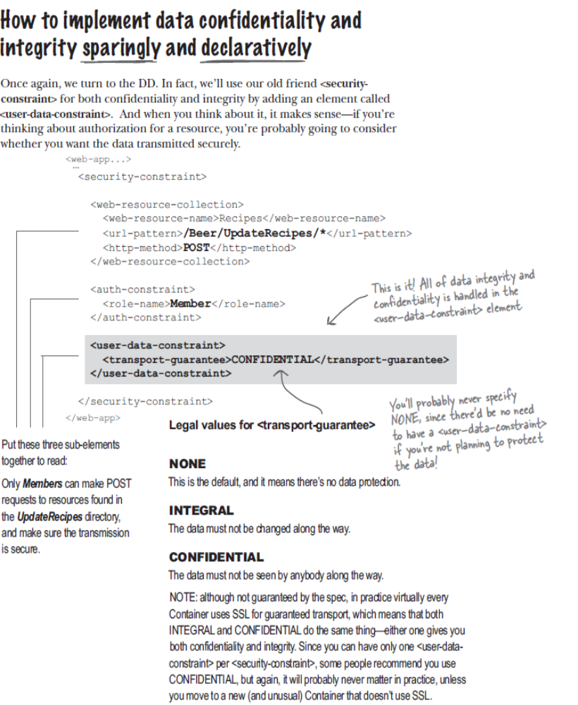

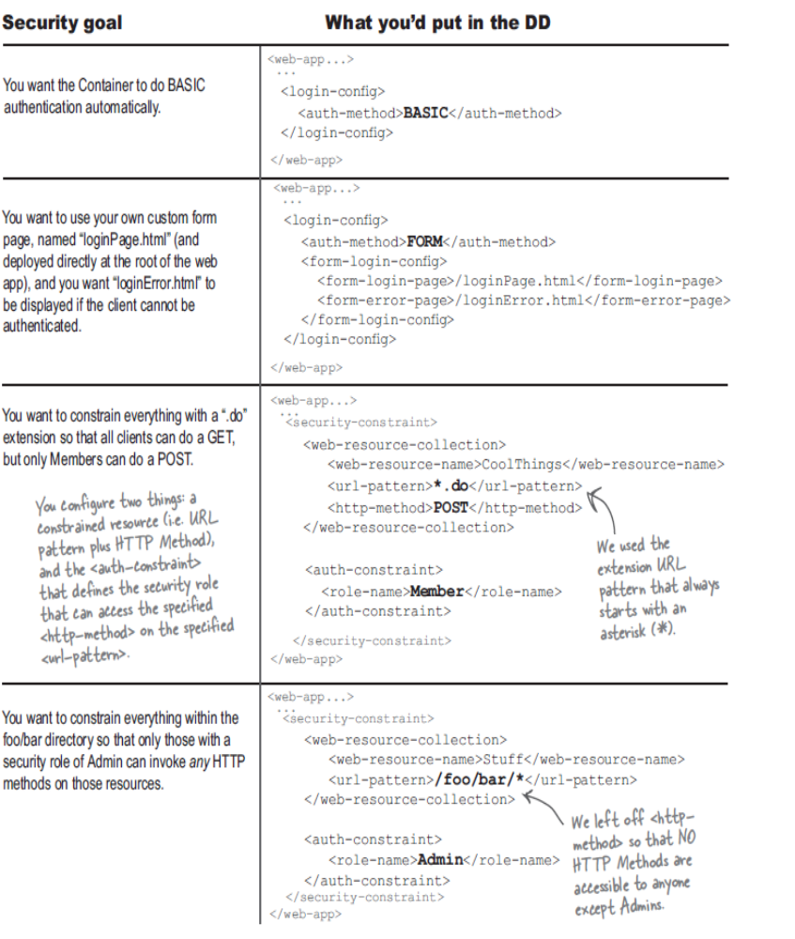

Deployment Concepts
Placing Files
- Tag File :
  - /WEB-INF/tags or
  - any subdir inside /WEB-INF/tags or
  - make a tag jar file and keep on any 2 of above place

